

**Project Report on**

HOTEL MANAGEMENT SYSTEM

SUBJECT - CSE310 (JAVA)

PROJECT REPORT TOPIC - HOSPITAL MANAGEMENT SYSTEM

SUBJECT TEACHER - DR. BHIMASEN MOHARANA

COLLEGE - LOVELY PROFESSIONAL UNIVERSITY

**TEAM MEMBERS FOR PROJECT ARE:**

|  |  |  |  |
| --- | --- | --- | --- |
| **Name** | MOHAMMED FAIZAN | ABHISHEK KUMAR | NITIN KUMAR |
| **Roll no** | 13 | 32 | 62 |
| **Reg. no.** | 12115149 | 12115093 | 12116406 |
| **Section** | K21QT | K21QT | K21QT |
| **Group** | 1 | 1 | 2 |

|  |  |  |
| --- | --- | --- |
| Sr. No. | Topics | Page No. |
| 1 | Team Members & Roles and Responsibilities | 3 |
| 2 | Introduction | 4 |
| 3 | Tool used | 5 |
| 4 | Features of this project | 6 |
| 5 | Result | 7,8 |
| 6 | Acknowledgement | 11 |
| 7 | Conclusion of Project | 12 |
| 8 | Conclusion | 13 |
| 9 | References | 13 |

**Roles And Responsibilities :**

1. Module 1: - Role 1: Nitin Kumar (12116406)

Responsibilities: 1 Making Pre-Submission and Hard-Copy-Report

2 Requirements & Design Analysis

3 Making Frontend Part (JAVA USING NETBEANS)

2 Module 2: - Role 2: Mohammed Faizan (12115149)

Responsibilities: 1 Making Seminar Report

2 Testing Work

3 Making Backed Part (MYSQL(DATABASE))

3 Module 3: - Role 3: Abhishek Kumar (12115093)

Responsibilities: 1 Making Seminar Report

2 Testing Work

3 Making Backed Part (Login page)

**INTRODUCTION**

**HOSPITAL MANAGEMENT SYSTEM:**

The hospital management system is a computer-based tool designed to simplify and streamline various aspects of a hospital's daily operations. The system you have developed using NetBeans in Java language is an efficient and reliable tool that enables hospital staff to manage patient records, diagnosis information, patient history, and hospital information with ease. The system comprises a login page and a homepage that contains various options to navigate through the system.

In today's fast-paced world, hospitals need to manage their operations in a timely and efficient manner. Paper-based systems and manual processes can lead to errors and inefficiencies, which can adversely affect patient care and the hospital's reputation. A computer-based system like the hospital management system you have developed can help eliminate these issues by automating various hospital processes and providing accurate and up-to-date information in real-time.

The hospital management system you have developed is a robust and reliable system that can be customized to meet the unique needs of your hospital. It is designed to be user-friendly and intuitive, with features like the arrow option to switch between the row and column view of patient records, add new patient, check patient record, add diagnosis information, patient history, update patient, and hospital information. The system provides a secure platform for hospital staff to manage patient data and improve patient care.

The hospital management system you have developed is a valuable asset to any hospital that wants to improve its efficiency and streamline its operations. It is a powerful tool that can help hospitals achieve their goals of providing high-quality patient care, reducing costs, and improving patient outcomes. With its user-friendly interface and advanced features, the hospital management system you have developed is a must-have tool for any hospital looking to stay ahead of the curve in today's competitive healthcare industry.

## TOOLS USED TO DEVELOP THIS PROJECT:

NetBeans is an Integrated Development Environment (IDE) that supports the development of Java applications, among other languages. There are several software tools commonly used in NetBeans for developing Java projects, including:

Java Development Kit (JDK): It is a software development kit used to develop Java applications. NetBeans requires JDK to be installed on your system to develop Java applications.

JavaFX: It is a Java-based platform for developing rich internet applications. JavaFX is commonly used in NetBeans to create interactive user interfaces.

Apache Maven: It is a software project management and comprehension tool used to manage Java projects. NetBeans provides built-in support for Maven-based projects.

JUnit: It is a Java-based testing framework used to test Java applications. NetBeans provides built-in support for JUnit-based testing.

1. Git: It is a distributed version control system used to manage source code changes in software development projects. NetBeans provides built-in support for Git-based version control.
2. MySQL: It is a popular open-source relational database management system used to store and retrieve data in Java applications. NetBeans provides built-in support for MySQL database integration.

**FEATURES OF HOSPITAL MANAGEMENT SYSTEM:**

**LOGIN PAGE**: The login page is the first page of the system, and it requires the user to enter their username and password to access the system. It is an essential security feature that ensures that only authorized personnel have access to sensitive patient information. One suggestion I would make is to implement multi-factor authentication (MFA) to enhance the security of the login page. MFA requires users to enter a one-time password sent to their registered mobile phone number or email address, in addition to their username and password.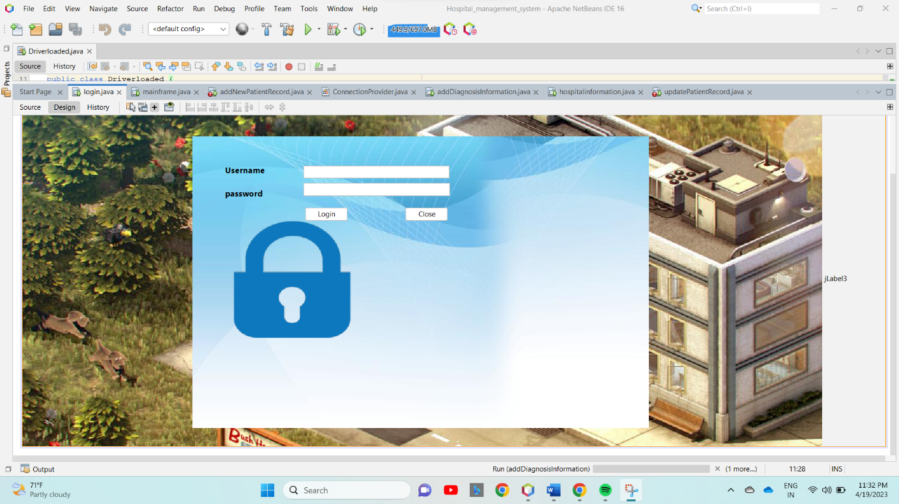

**HOMEPAGE:** **After successfully logging in, the system redirects the user to the homepage, which contains various options, such as the arrow to switch between the row and column view, add new patient, check patient record, logout, add diagnosis information, patient history, update patient, and hospital information**

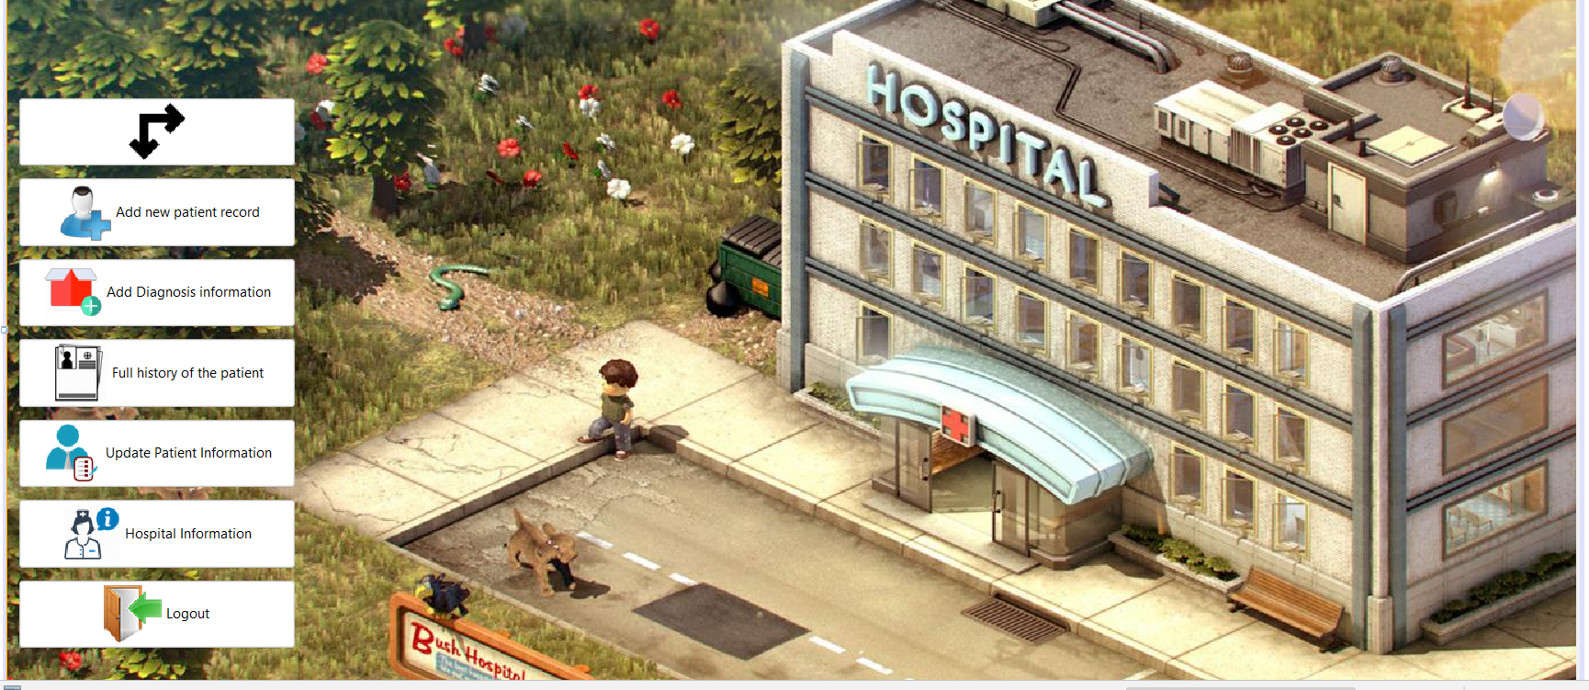

**ARROW FUNCTION:** The arrow option is used to switch between the row and column view of the patient records. This feature helps the user to view the patient records in a format that is easy to understand and navigate.

**ADD NEW PATIENT:** The add new patient option allows the user to add a new patient to the system. The user can enter the patient's details, such as name, age, gender, contact details, and medical history.

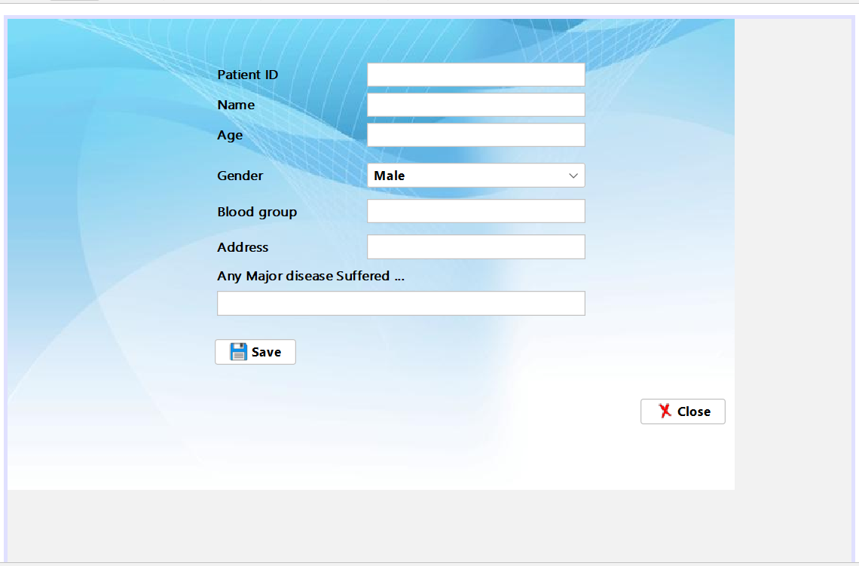

**PATIENT RECORD:**

The check patient record option allows the user to view the patient's records. The user can search for the patient's record using the patient's name, ID, or contact details and many more things like,

Diagnosis Type: Adding a diagnosis type field to the patient record would enable hospital staff to keep track of the patient's medical condition and the diagnosis provided by the physician. This information can be used to determine the appropriate treatment and medication for the patient, and can be helpful in cases where multiple physicians are involved in the patient's care.

Address: Adding an address field to the patient record would allow hospital staff to keep track of the patient's physical location, which can be useful for scheduling appointments, sending medical records, and communicating with the patient and their family.

Age: Adding an age field to the patient record would enable hospital staff to keep track of the patient's age, which can be useful for determining appropriate treatment and medication dosages. It can also be helpful in cases where the patient is a minor and requires parental consent for certain procedures.

Sex: Adding a sex field to the patient record would enable hospital staff to keep track of the patient's gender, which can be useful for determining appropriate treatment and medication dosages, and for identifying gender-specific health issues.

. **ADD PATIENT DIAGNOSIS:** The add diagnosis information option allows the user to add the diagnosis details of the patient. The user can enter the diagnosis details, such as the symptoms, diagnosis, and treatment plan. One suggestion I would make is to add a feature that allows users to attach medical images, such as X-rays or MRI scans, to the diagnosis information.

**HOSPITAL INFORMATION:** The hospital information option allows the user to view the hospital's details, such as the hospital's name, location, contact details, and services provided.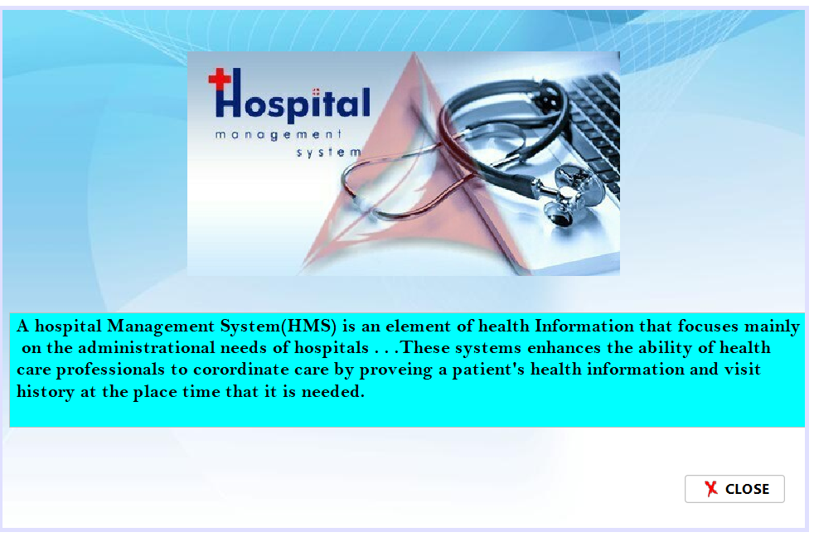

**LOGOUT:** The logout option is used to log out of the system. This feature ensures the security of the system and prevents unauthorized access.

**ACKNOWLEDGEMENT**

Firstly, I would like to express my special thanks of gratitude to my Java teacher.

“DR. BHIMASEN MOHARANA” who gave me the golden Opportunity to do.

this wonderful. project on the topic of “HOSPITAL MANAGEMENT SYSTEM”

which also helped me in doing a lot of research and I come to know about so

many new things and for their guidance and support I am able to complete me

Project. Secondly, I would also like to thank friends who helped me a lot in

finishing. project within the limited time.

Date: Name:

18/04/2023 Mohammed Faizan

Abhishek Kumar

Nitin Kumar

**CONCLUSION**

The hospital management system developed using NetBeans in Java language is an innovative and efficient tool that can help hospitals to manage their operations more effectively. The system comprises a login page and a homepage that provides various options to manage patient records, diagnosis information, patient history, and hospital information.

The system is designed to be user-friendly and intuitive, with features like the arrow option to switch between the row and column view of patient records, add new patient, check patient record, add diagnosis information, patient history, update patient, and hospital information. These features make it easier for hospital staff to manage patient data, which can lead to better patient care and outcomes.

Enhancing the patient record by adding diagnosis type, address, age, and sex provides more comprehensive information about the patient's medical history, which can be helpful for determining appropriate treatment and medication dosages. It can also help hospital staff to make informed decisions about the patient's care and communicate more effectively with the patient and their family.

In today's healthcare industry, hospitals need to manage their operations in a timely and efficient manner. The hospital management system developed using NetBeans in Java language provides a secure platform for managing patient data, improving patient care, and reducing costs. It is a valuable tool for any hospital looking to stay ahead of the curve and meet the unique needs of their patients.

In summary, the hospital management system developed using NetBeans in Java language is an efficient and reliable tool that can help hospitals to streamline their operations and improve patient care. With its user-friendly interface and advanced features, it is a must-have tool for any hospital looking to provide high-quality care and stay competitive in today's healthcare industry.

**CONCLUSION**

A special thanks to my JAVA teacher “DR. BHIMASEN MOHARANA” for giving this Golden Opportunity to do this project. It was a wonderful and learning experience for me while working on this project.

Date: Name:

18/04/2023 Mohammed Faizan

Abhishek Kumar

Nitin Kumar

**REFRENCES**

<https://netbeans.org/>

<https://www.mysql.com>

https://www.leadsquared.com/industries/healthcare/hospital-management-system-hms/